# Proof of Concept (PoC) Documentation

**Project Title:** Nmap & Notepad++ Utility Tools

**Name:** Gautam Poojari  
**Intern ID:** 251  
**Date:** 25-07-2025

### **Objective:**

To demonstrate the installation, usage, and benefits of using **Nmap** for network scanning and **Notepad++** for secure and efficient source code editing.

### **1. Nmap: Network Scanning Tool**

**Description:**  
Nmap (Network Mapper) is an open-source tool used for network discovery and security auditing. It can quickly scan large networks and detect live hosts, services, and open ports.

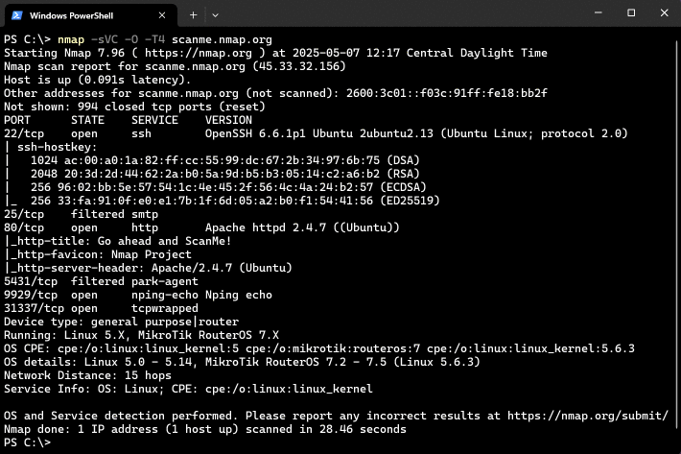

**Installation:**

* **Windows:** Download from <https://nmap.org/download.html>
* **Linux:**

sudo apt install nmap

**Usage Example:**

nmap -sV 192.168.1.1

**Expected Output:** List of open ports and services running on the target IP:

PORT STATE SERVICE VERSION  
22/tcp open ssh OpenSSH 7.6  
80/tcp open http Apache httpd 2.4.29

**Use Case:** Nmap helps identify vulnerabilities and verify the security posture of systems by revealing open ports and running services.

### 

### PHP Tutorial 27 - MySQL Creating A Table (PHP For Beginners) - YouTube**2. Notepad++: Code & Text Editor**

**Description:**  
Notepad++ is a free and powerful text/code editor for Windows. It supports various programming languages, plugins, and syntax highlighting.

**Installation:**

* Download from <https://notepad-plus-plus.org/>

**Usage Example:**

* Open source code files (.py, .js, .html, etc.)
* Use built-in features like line numbering, code folding, and plugin integration (e.g., compare, auto-indent)

**Use Case:** Notepad++ improves developer productivity and is safer to use for viewing potentially malicious scripts than Word or other rich-text editors.

### **Best Practices:**

* Use Nmap scans in a legal and authorized environment only.
* Always update Notepad++ and use trusted plugins to avoid vulnerability exposure.

### **Conclusion:**

Nmap is an essential tool for reconnaissance and network security analysis, while Notepad++ is a reliable, lightweight code editor useful for secure script and code review.